LeetCode Program 2169
Link :- https://leetcode.com/problems/count-operations-to-obtain-zero/
Successful Submission
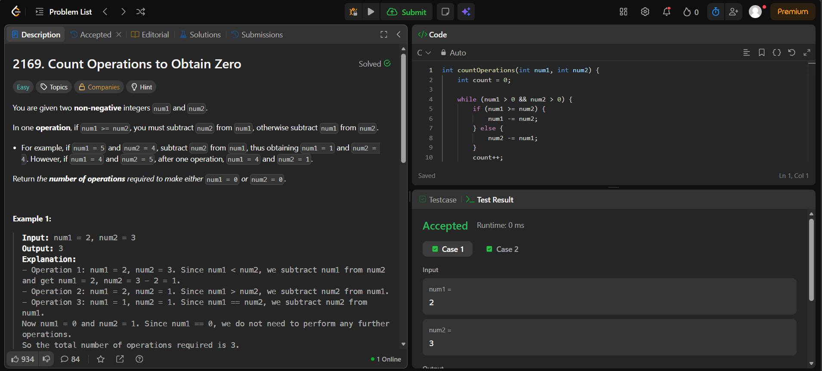
Source Code


